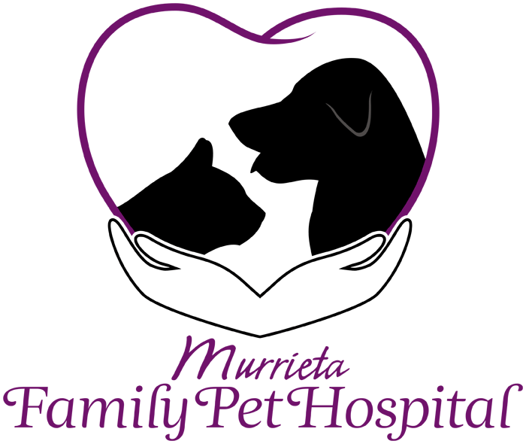
New Client Information Form
Welcome to Murrieta Family Pet Hospital! Our staff is dedicated to the optimum in patient care and will do its utmost to make your pet’s stay pleasant and beneficial. Please feel free to ask any questions concerning the treatment of your pet or other policies of the hospital. To help us serve you better, please provide the following information.

Owner Name ________________________________________ Email Address _____________________________________________
Address __________________________________________ City __________________________ State ________ Zip _____________
Cell Phone __________________________ Home Phone __________________________ Work Phone _________________________
Co-Owner Name ___________________________________________ Phone ________________________________
How did you choose our practice? Website Location Other (specify) ___________________________
Personal Recommendation (whom may we thank?) _________________________________________
Who is your pet’s medical insurance provider? _______________________________ Policy number ________________________

Patient Information | Pet #1 | Pet #2 | Pet #3
Name
Breed
Date of Birth
Color
Sex: (circle) | Female Male  Spayed Neutered | Female Male  Spayed Neutered | Female Male  Spayed Neutered
Previous illnesses or surgeries?
Allergies to vaccinations or medications?
Special diets or medications?

Photo Consent: I grant Murrieta Family Pet Hospital the right to take photographs of my pet, and to copyright, use and publish the same in print and/or electronically. I agree that Murrieta Family Pet Hospital may use such photographs of my pet for any lawful purpose, including, for example, such purposes as publicity, illustration, advertising, and Web content.
The above may take photos of my pet The above may NOT take photos of my pet

Please note: Your privacy is important to us.
All information received in all forms and through other communications is subject to our Patient Privacy Policy.

All payments are due at the time of services rendered. We accept cash, checks, all major credit cards, and Care Credit, which can be approved in as little as 10 minutes.

Signature _____________________________________________________ Date_____________________________

